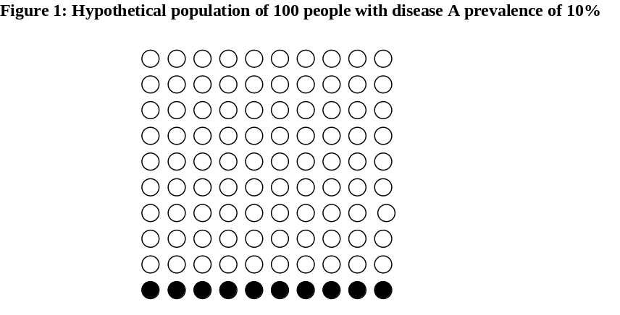

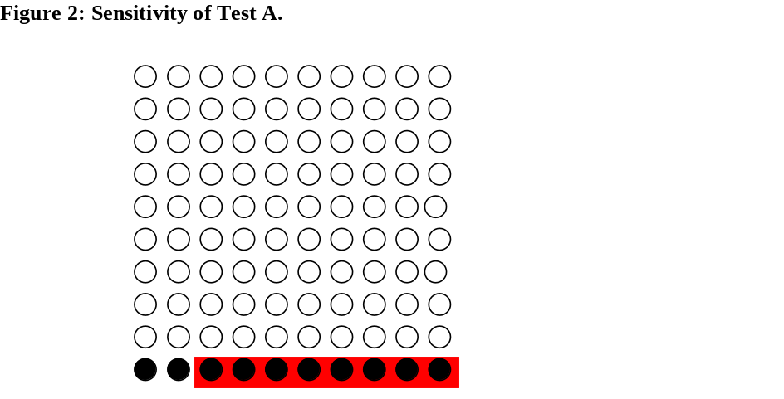recall

proportion of people with disease who test positive Sensitivity tells us nothing about whether or not some people without the disease would also test positive and, if so, in what proportion.

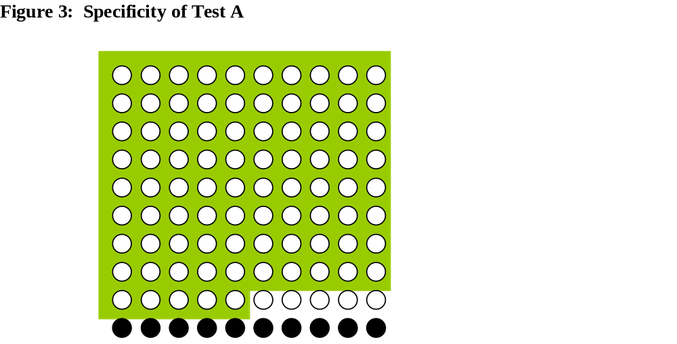

Those in a green background are without disease who tested negative. Specificity is calculated as number of white dots in a green background (people with disease who tested negative) divided by the total number of white dots (all people without disease).
Akobeng Understanding diagnostic tests 3 receiver operating characteristic curves suppl apa180figs

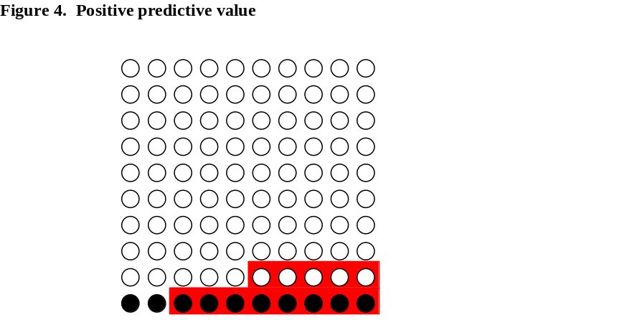

In the hypothetical population of 100 people, you will recall that 8 people with Disease A had a positive result for Test A, and 5 people without disease also tested positive. This means that a total of 13 people tested positive.Figure S4 shows these 13 people in a red background. Out of these 13 people, only 8 of them actually had the disease (black dots). From Figure S4, the PPV of Test A is calculated as the number of people with Disease A who tested positive (the number of black dots in red background)divided by the total number of people who tested
positive (the total number of dots in red background) which is 8/13 = 0.62 or 62%. This means that, in this hypotheticalpopulation, 62% of people who test positive will have Disease A, or put in another way, a person who has a positive test has a 62% chance of having Disease

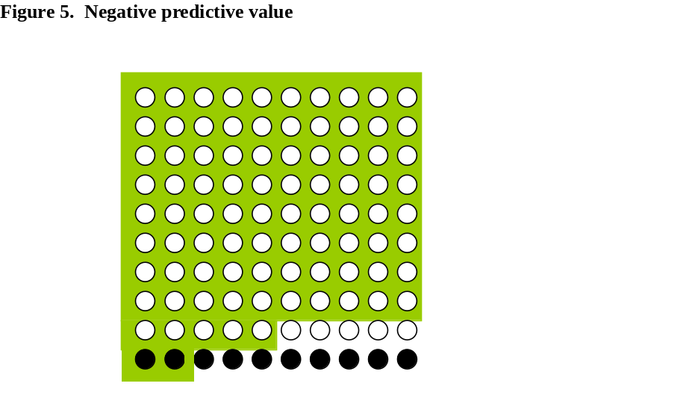
Meaning of colours in these figures. Red- tested positive, green tested negative
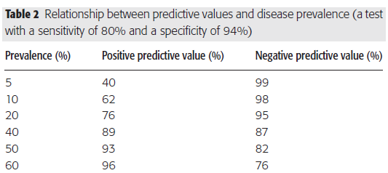We need estimation of prevalence

